**UNIT 3**

**Reading Comprehension**

**Course Objective:** To improve students’ comprehension skills required for academic and professional needs.

**Course Outcome:** Improve comprehension skills through intensive and extensive reading practice.

**TOPIC: Understanding short real world notices, messages, factual material - Skimming & Scanning**

**Model Questions:**

1. ‘Please Keep This Entrance Clean’. What does this sign mean?
2. What does this notice mean?

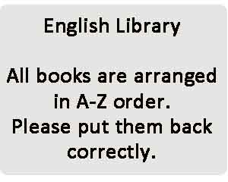

1. What does this notice mean?

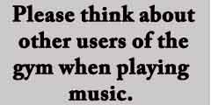

1. What is Skimming? Explain
2. What is scanning? Explain
3. What is detailed reading? Explain
4. What are different types of reading techniques? Explain
5. Read the passage. Answer each question in a complete sentence.
6. How do you infer the meaning from the author’s point of view?
7. Prepare a tree diagram by using given information.
8. Discuss in detail the reasons for poor comprehension in reading.
9. What is critical reading? Explain
10. What are critical reading strategies? Explain
11. What is the difference between critical reading and critical thinking? Explain the techniques used in critical reading.

**Comprehension:**

Comprehension is the understanding and interpretation of what is read. To be able to accurately understand written material, you need to be able to (1) decode what you read; (2) make connections between what you read and what you already know; and (3) think deeply about what you read.

**Reading Comprehension:**

Reading is a method of communication that enables a person to turn writing into meaning. It allows the reader to convert a written text into a meaningful language with independence, comprehension, and fluency, and to interact with the message.

**7 Reading Techniques or Styles:**

1. Scanning
2. Skimming
3. Active Reading
4. Detailed Reading
5. Speed Reading
6. Structure-Proposition-Evaluation
7. Survey – Question – Read – Recite - Review

Reading is a great habit that can change human life significantly. It can entertain us; amuse us and enrich us with knowledge and experiences narrated. There exist some reading techniques, which if mastered at a growing stage can help us, be better and far more comprehensive readers. These skills might not necessarily be learned as rigid theories or rules but if understood well once, they can definitely enhance the reading skills and increase the quality and quantity of output that we get from after reading.

The followings are seven styles/techniques of reading used in different situations:

**1. Scanning**

Scanning through the text is a reading strategy that is used for getting some specific points by looking at the whole text. This could be used when you need to find the information quickly. You can use the scanning technique to look up a phone number, read through the small ads in a newspaper, for browsing television schedules, timetables, lists, catalogues or web pages for information. For these tasks you don’t need to read or understand every word. Scanning is also useful when you don’t have time to read every word.

**How do you scan the text?**

* Don’t try to read every word. Instead let your eyes move quickly across the page until you find what you’re looking for.
* Use clues on the page, such as headings and titles, to help you.
* Use the header words to help you scan. You can find these in bold type at the top of each page.

**2. Skimming**

Skimming is a reading technique that can help you to read more quickly, decide if the text is interesting and whether you should read it in more detail. This technique is used for getting the gist of the whole text read. We generally use this technique at the time of reading a newspaper or magazine. It is useful in getting a preview of a passage before reading it in detail or reviving understandings of a passage after reading it in detail.

**How do you skim the text?**

* Don’t read the whole text word for word.
* Look if there are any pictures or images related to the topic, or an eye-catching title.
* Look out for key words
* Read the title, subtitles and subheadings to find out what the text is about.
* Read the first and last sentence of each paragraph.

**3. Active Reading**

Active reading aims to get an in-depth understanding of the text. Under this technique, the reader actively involve with the text while reading it. Getting in-depth knowledge of the text is not possible by skimming through or scanning through the text.

**4. Detailed Reading**

This technique is used for extracting information accurately from the whole text. Under this technique, we read every word for understanding the meaning of the text. In this process, we skim the text first for getting a general idea and then read it in detail. We can use a dictionary to find the meaning of every unfamiliar word.

**5. Speed Reading**

Speed-reading is actually a combination of various reading methods. The aim of speed-reading is basically to increase the reading speed without compromising the understanding of the text reading. Some of the strategies used in speed reading are as follows:

* Identifying words without focusing on each letter
* Not to sounding-out all words
* Not sub-vocalizing some phrases
* Spending less time on some phrases than others
* Skimming small sections

**6. Structure-Proposition-Evaluation**

This is an interesting reading technique suggested by Mortimer Adler in his book “How to Read a Book.” This reading technique is mainly applicable to non-fiction writing. This technique suggests reading as per the three following patterns:

* Studying the structure of the work
* Studying the logical propositions made and organized into chains of inference
* Evaluation of the merits of the arguments and conclusions

**7. Survey-Question-Read-Recite-Review**

This method aims to facilitate a clear understanding of the text that the reader has learned during the process of reading. The process involves five different steps, which are as follows:

**Survey**The survey involves getting a quick idea of the whole writing piece. For example, reading the introduction or summary of a book will be enough to get an idea of that book.

**Question**  
We are not just reading the words or looking at the words but are actually trying to make out the underlying meaning of the text. So we should prepare questions in our mind and look for the answers while reading the text.

**Read**  
The reader should read selectively if they are looking for any specific information.

**Recite**  
The reader should answer the questions in his own words using only the keywords that are required to sum up the complete idea.

**Review**  
The reader should review the entire things in his mind.

**Intensive Reading and Extensive Reading:**

Reading is the basic foundation on which academic skills of individuals are built. Many believe that reading is a true measure of a person’s success in academics. Most of the subjects taught to us are based on a simple concept – read, understand, analyze, synthesize, and get information.

**Intensive Reading:**

•Intensive reading is the most time-consuming of all the reading techniques.

•The main goal here is to retain information for the long-term.

•This method is recommended especially for language students, as it helps them truly grasp the meaning of

the words in context.

• But it’s also great for analyzing reports and detailed research.

•Used in conjunction with skimming and scanning, intensive reading can widen your horizons and help you

keep important information longer.

**Read intensively:**

•To understand a subject or a concept clearly

•When you get new contracts, business proposals, or memos

•When you are using the company chat room or replying to emails

**Extensive Reading:**

•Extensive reading focuses on reading for pleasure.

•You choose your own material, your pace, as well as how you’ll interpret the content of what you’ve just

read.

•This strategy is great not only for fiction works, but also if you want to improve your writing, and

expand your vocabulary.

***************************************************************************************

**Topic : Inferring Meaning**

**How do you infer the meaning from the author’s point of view?**

Making inferences is an analytical strategy that draws a conclusion based on specific evidence, including prior knowledge. For instance, if a co-worker showed up to work with a cast on his arm, you could infer that he broke his arm since you know doctors put casts on broken bones.

**Points to be memorized:**

1. Writers often tell readers more than they say directly. They give hints or clues that help

readers "read between the lines." Using these clues, drawing a conclusion is called inferring.

1. Making inferences is a way of connecting unknown information with the known. To do this,

you analyze events, facts, ideas, objects and sensations and compare them with what you already know.

1. When you infer, you go beyond the surface details to see other meanings that the details

suggest.

**Guide to making an inference**

Use these steps to help you make an inference:

**Identify the premise**

When making an inference, first identify what you are inferring. This allows you to focus on what you are trying to understand. For example, if you see your brother carrying a baseball, you may want to make an inference in regards to what your brother is doing.

**Ask a question**

After identifying your premise, you can ask a question about what is happening/occurring etc.

**Search for clues**

Next, look for clues that may help you make your inference. You can do this by observing the situation.

**List relevant details**

Create a list of relevant details that may help you determine what's happening in a text.

**Narrow down the choices**

Once you have a list of details, begin eliminating the ones that are probably unlikely. Doing this can help you reach your logical conclusion.

**Make your inference**

Finally, put your observation and knowledge together to make your inference.

**Factors that affect poor reading comprehension are:**

Reading comprehension is a cognitive process that requires many skills and techniques. The factors that affect poor reading comprehension are:

**1. Background Knowledge**

Background information plays an important role in understanding reading. In an effort to understand the text, readers rely on their background knowledge to link what they already know to the text they are reading. Drawing similarities between background information and texts helps readers to become more active, improving their reading comprehension.

**2. Vocabulary**

Vocabulary skills of readers will affect their reading comprehension. Readers should be able to understand a word they read and its relationship to other words within the text. Proper understanding of vocabulary involves seeing part of a sentence, an explanation, helpful contextual clues, and how it works in a sentence. These word techniques can help improve reader’s comprehension.

**3. Fluency**

Fluency allows learners to store information with precision, expressiveness and increased speed. The ability to read fluently is developed through practice. As learners become fluent readers, they will spend less time trying to understand the meaning of words and more time considering the meaning of sentences. Over time, fluent readers will develop the ability to respond with understanding of the text.

**4. Active Reading**

The Beginners often rely on skilled learners to guide them through the text. However, as beginners develop and grow older they are able to monitor the reading comprehension. Learners can solve comprehension problems by remembering what they have read, asking themselves questions or checking the text.

**************************************************************************************

**Topic: Critical Reading**

**What is critical reading?**

Critical reading is a form of language analysis to a certain extent, involving a deeper examination of the text, the ideas, themes and claims presented. Critical reading involves a higher level of involvement from a reader than general reading. The reader is supposed to apply certain theories and thought processes, raise questions and the final result is better comprehension and enhanced clarity. As a process, this means that the reader should always keep an open mind, read slower than usual, pay extra attention, take notes and try to put himself or herself in the shoes of the author’s target audience.

**Why is critical reading important & what are the benefits of critical reading?**

Critical reading plays an important role in the reader’s understanding of a text and takes things to a new level. Here’s why critical reading is important.

**Mental development**

Critical reading has an effect on our minds. Like any complex mental task we take on, critical reading is actually an even better exercise. By getting more involved in the text, taking notes, analyzing more aspects of the language and subtext, more areas of our brain will be activated compared to classical reading. The neuronal connections are being strengthened, new neural paths are built and our brains develop better and faster.

**Better understanding of the text**

Reading critically has an immensely positive effect on how much, how well and how quickly we understand what we read. Critical reading means no stone is left unturned. Reading critically implies a level of involvement in the activity of reading that doesn’t allow us to skip any unknown words, any connections to other events the author is making, which in turn means the reader understands it 100%.

**Critical thinking**

Critical thinking is an essential life skill, defined as one’s ability to understand, synthesize, conceptualize, analyze, interpret and evaluate information. Critical reading is a powerful tool in developing the necessary mental attributes of a critical thinker. This type of reading is an essential mental exercise through which information read is being analyzed and processed at a much deeper level.

Any thought, idea or concept expressed by the author needs to be observed, judged and carefully analyzed while critically reading. The same mental process is involved in critical thinking. For example, being able to distinguish between real and fake news is absolutely essential nowadays. That is the power of critical thinking and critical reading is therefore a great means to this end.

**Remembering more from what you read**

It’s usual for us to forget many parts of what we read. Our brains normally decide what information is worth keeping and what can be forgotten. Best we can do when it comes to our memory is nudge it in the right direction whenever we feel that we absolutely need to remember a certain piece of information. And even though it may sound odd, we do that using tricks. Tricks like repeating a name several times in order to remember it, writing down essential information etc.

Critical reading uses some of the same tactics: it is not unusual for a reader to go over the same paragraph several times before being completely sure all the information is understood, a critical reader will often take notes in order to structure the gathered information in a more facile manner.

As mentioned earlier, this process of analyzing the text to a deeper level gets more parts of our brain involved, which in turn tricks it into creating the neuronal connections that are required for remembering a lot more information than you would through regular reading.

**Better logical and problem solving skills**

Like any mental exercise, critical reading has effects that go way beyond the obvious. While at first glance, it would seem logical for critical reading to have benefits that are strictly related to reading, speech and text comprehension, things are quite different in reality. This leads to better decision making, a decluttered mind, crisper logic and even an ability to solve problems faster, better and with less effort.

**What are the critical reading strategies & how to read critically?**

The best critical reading strategies are:

**Read normally**

The first time around, read the given paragraph just to get a rough idea about the theme, main idea. It’s fine to just skim it to get prepared for the next steps. Read again, more carefully. Read each sentence carefully, trying to understand the main concepts and pay attention to details. Don’t hesitate to repeat this step until you’re comfortable to move on.

**Make notes**

Write down the important aspects of the text and any particularities that stand out. Make a note of any questions you feel you should be able to answer later. Jot down how the piece of writing makes you feel, whether you agree or not with the points made.

**Understand every word**

Search for any words you are unfamiliar with, do research about historical events or concepts that are mentioned so you better understand the context.

**Analyze every word**

Pay attention to what kind of words are used and try to understand why. Put yourself in the author’s shoes and try to imagine why the ideas or thoughts are expressed using those particular words. Is the author trying to convince you to believe a concept or philosophy, or just trying to entertain you?

**Practice metacognition**

Try to understand what you are thinking about what the author is thinking. Challenge the ideas, concepts, decide whether you agree with the author’s point and why. Try to imagine if there could have been a better way for the writer to present those ideas.

**Draw your conclusions**

Once you are comfortable with the mental process you filtered all the information through, decide for yourself if that particular paragraph was your cup of tea, if you enjoyed reading and analyzing it, what you learned, and to what extent you agree with the writer’s ideas and how he expressed them.

*************************************************************************************

**Topic: Reading and information transfer**

**What is Information Transfer?**

* Transferring information from **verbal to graphic form**, and vice versa is thus a very useful skill in effective presentations.
* The information can be shown through texts, tables, maps tree diagrams bar graphs, pie charts, flow charts and so on.
* Information in verbal form can be made clearer and easier to understand by presenting it in graphic or pictorial form.

**Pictorial representation has many advantages:**

* Allows quick and easy viewing of a large amount of data
* Quicker to locate required information in a graphic than in a written text.
* Data relating to a long period of time or to large number of people can be effectively summarized.
* Convenient to use in making comparisons involving large amounts of data

**Points to be remembered:**

* The different types of graphic representation you could use to supplement your writing are: **tables, bar charts, maps, graphs, pie charts, tree diagrams, flow charts and pictograms.**
* When you need to use a graphic form of communication, choose a form that will present your data clearly, accurately and in an interesting manner.
* When information is personated graphically, you should be able to **interpret or analyze it.**
* Transferring information from textual to graphic form and, conversely, from pictorial to verbal form are both important and useful communication skills.

**Uses of different forms:**

* **TABLES** A simple form of graphic representation is the table, in which data are arranged in horizontal rows and vertical columns that carry labels to identify what they represent.
* **BAR CHARTS** A second kind of graphic representation is the bar chart, or bar graph. It is a very common kind of graph used to depict levels of a qualitative, independent variable using individual bars. It consists of an axis and a series of labeled horizontal or vertical bars with different values. The numbers along one side of the bar graph is the scale.
* **LINE GRAPHS** A line graph is a way of depicting graphically how two quantities are related, and how they vary in relation to one another.
* **PIE CHARTS** Another kind of chart is the circle chart or pie chart. It consists of a circle divided into sections, each showing the size of some related piece of information.
* **FLOW CHARTS** Another form of representation that is widely used today is the flow chart, also known as a flow diagram. It is used to represent a process that takes place in successive stages, as in a production process from raw material to finished product.
* **TREE DIAGRAMS** Tree diagrams are two types: organization chart, which is used to show the structure and lines of responsibility within a company or an institution, and the genealogical tree or family tree, which is used to represent the structure of a major group such as mineral rocks or the structure of sentences in books on grammar or relationships within a large family.
* **PICTOGRAMS** A pictogram is another very interesting way of presenting data. It uses, as its name suggests, pictures in place of bars or figures. For example, the flowers growing in different places in a state or a country can be presented by tiny pictures.
* **MAPS AND PLANS** Maps are representations, usually on a plane surface, of a part of the earth-continents, countries, cities, villages, small areas and even buildings. They show outlines and boundaries, names or codes of areas within them and features such as roads, coastlines, rivers, buildings and rooms.

**Sample Pie Chart**

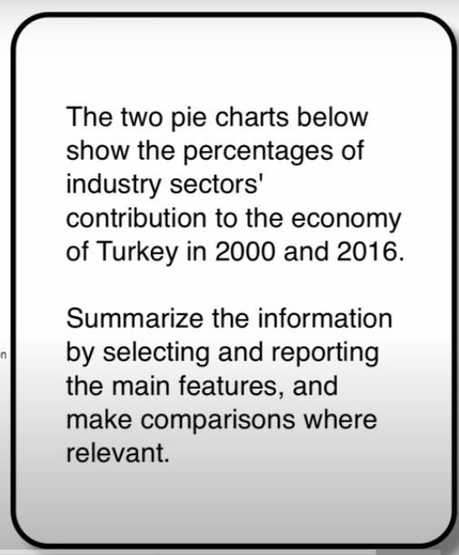

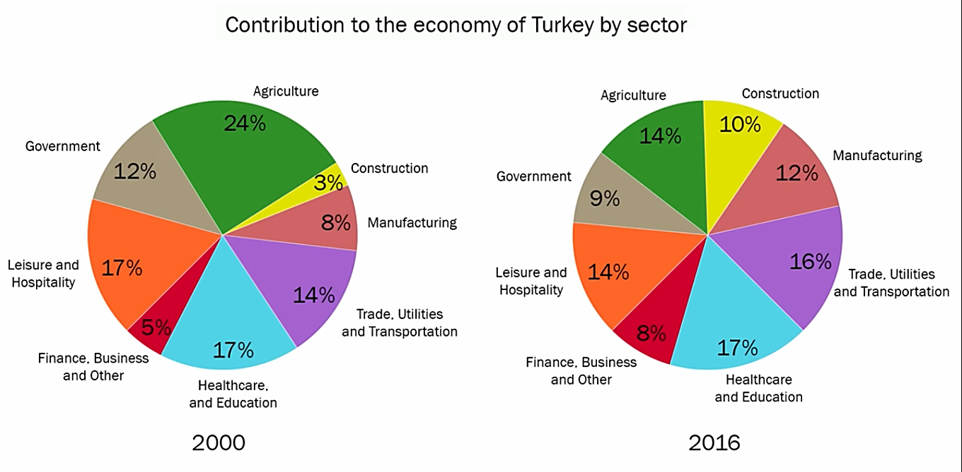

The two pie charts illustrate how different industry sectors contributed to the economy of Turkey percentagewise in the years 2000 and 2016.

Overall, at the beginning of the period construction Contributed the least to the economy of Turkey, While agriculture was the most significant sector. In comparison, at the end of the period healthcare And education became the largest economic segment and the lowest contribution and made by finance, business and other services.

Construction sector accounted for 3% of Turkey’s economy in 2000, and experienced a more than threefold increase to one-tenth in 2016. Economic income from trade, utilities and transportation was 14% in 2000 and had a slight growth of 2% in 2016. At the beginning of the period, manufacturing and finance, business and other services made up 8% and 5% of Turkey’s economy respectively, and these figures rose to 12% and 8% in 2016.

Agriculture, which comprised almost a quarter of Turkey’s economy in 2000, fell to 14% in 2016. In 2000 economic outputs from government and leisure and hospitality sectors were at 12% and 17%, respectively, and both decreased by 3% after 16 year period. In contrast, contribution from healthcare and education sector remained constant in both years at 17%.

***************************************************************************************